- Copyright for test papers and marking guides remains with West Australian Test Papers.
- The papers may only be reproduced within the purchasing school according to the advertised conditions of sale.
- Test papers must be withdrawn after use and stored securely in the school until Wednesday 19th October 2011.



YEAR 12 PHYSICS

STAGE 3

2011

MARKING GUIDE

Structure of this paper

Section | Number of questions available | Number of questions to be answered | Suggested working time  (minutes) | Marks available | Percentage of exam
Section One:  Short answer | 13 | 13 | 50 | 54 | 30
Section Two:  Extended answer | 8 | 8 | 90 | 90 | 50
Section Three:  Comprehension  and data analysis | 2 | 2 | 40 | 36 | 20
 |  |  | Total | 180 | 100

Instructions to candidates

1. The rules for the conduct of Western Australian external examinations are detailed in the Year 12 Information Handbook 2010. Sitting this examination implies that you agree to abide by these rules.

2. Write answers in this Question/Answer Booklet.

3. You must be careful to confine your responses to the specific questions asked and follow any instructions that are specific to a particular question.

- Working or reasoning should be clearly shown when calculating or estimating answers. It is suggested that answers to calculations are given to 3 significant figures except when you are required to estimate. For estimation questions an appropriate number of significant figures must be stated.

5. Spare pages are included at the end of this booklet. They can be used for planning your responses and/or as additional space if required to continue an answer.
  - Planning: If you use the spare pages for planning, indicate this clearly.
  - Continuing an answer: If you need to use the space to continue an answer, indicate in the original answer space where the answer is continued, i.e. give the page number. Refer to the question(s) where you are continuing your work.

Section One: Short response 30% (54 Marks)

This section has 13 questions. Answer all questions. Write your answers in the space provided. Suggested working time for this section is 50 minutes.

Question 1
A sound wave travels through water to meet a boundary with a solid concrete wall of a dam.
Sound wave
Water
Solid Concrete Wall

- Draw a possible path of the sound wave as it refracts into the concrete. Indicate appropriate angles.
Shows refraction away from normal, indicates refraction angle greater than incidence angle. ✓
(1)

- The wave fronts in the water are shown on the diagram. Indicate the general pattern of wave fronts when the sound wave travels in the solid concrete wall.
Shows larger spacing which indicates faster in concrete ✓
(1)

- Is it possible for total internal reflection to occur at this boundary? Explain briefly.
(1)
Yes this can occur if second medium has higher wave speed. ✓

NS
N

S
Compass
Question 2
Two identical magnets are fixed in position on a flat bench. A compass is placed near the magnets.

- Sketch the magnetic field in the region around the magnets. Draw at least 4 field lines for each magnet.

(2)

- Indicate the direction that the compass needle will point by placing an arrow in the circle.
(1)
Aligns with vector addition of 2 component fields. ✓
Question 3
By banking the curves of racetracks it is possible for vehicles to turn in a horizontal circle without relying on friction. For a car of mass 1 700 kg the angle of banking is set at 13.4° above the horizontal. The curve has a radius of 171 m and the car drives at a speed to maintain its height.
Vector diagram
ΣF or F_{c}

Weight 13.4° Normal Reaction

13.4°

- Draw a vector diagram showing the forces acting on the car and the sum of those forces in the space indicated above.
(1)
- Calculate the centripetal force acting on the car.
(3)
W = m.g = 1700 × 9.8 = 16 660 N

tan 13.4 = opp / adj = ΣF / W

ΣF = mg × tan 13.4° = 16 660 × tan 13.4°✓
ΣF = 3.97 × 10³ N ✓ towards centre of circle ✓

Question 4
Aluminium-29 decays to Silicon-29 by beta emission as described in the nuclear equation:
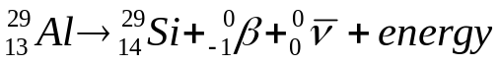
  - Identify the particle with the symbol 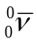
Anti-neutrino. ✓
(1)

  - The beta particle is an electron that has come from the nucleus. Explain how the beta particle and the particle appeared. [Useful information is as follows: The quark composition of a proton = up + up + down, the quark composition of a neutron = up + down +down.]
(3)
Consider one of the neutrons in the aluminium nucleus.
One of the down quarks in the neutron ✓decays into an up quark, a beta negative particle and an anti-neutrino. ✓
The neutron has become a proton which remains in the nucleus (now Silicon) and the beta negative particle and the anti-neutrino are ejected. ✓ (knowledge of the intermediate virtual W-boson is desired but not necessary)

Question 5
An iron ball of mass 220 kg is suspended from the end of a rigid steel girder.
Steel wire
Pivot point
1.60 m
50º
Girder mass 180 kg
Rigid upright
Iron ball
mass 220 kg
65º
Action force from weight
= 220 × 9.8
Weight
= 180 × 9.8
Reaction from pivot
Tension
Diagram is not drawn to scale.

The girder has a mass of 180 kg and a length of 2.40 m.

The girder is pivoted to a rigid upright.

A steel wire is attached 1.60 m along the girder. It holds it in equilibrium with angles between components as shown in the diagram.

- Identify all the forces acting on the girder by drawing them on the diagram.
Identifies all 4 forces✓
(1)

- Demonstrate by calculation that the tension in the steel wire is 5.39 × 10³ N.
(3)
Take moments about pivot ΣM = 0 M = r.F.sin θ
Σacwm = Σcwm
1.60×T×sin 50 = (1.20×180×9.8×sin 65) + (2.4×220×9.8×sin 65)
correct lever arms ✓ recognises sin θ for all torques ✓

T = 6608.071 / (1.60 × sin 50) = 5391.39
T = 5.39 × 10³ N ✓ (along the wire)

Question 6
Refer to the diagram and description in Question 5. If the tension in the steel wire is 5.39 × 10³ N calculate the magnitude and direction of the reaction force from the pivot acting on the steel girder.
Combined action of weights down
(220 +180) × 9.8 N
3920 N
Tension
5.39 × 10³ N
Reaction Force
65°
Φ
Φ
(4)

Consider that ΣF = 0
Correct vector diagram (or component analysis)✓
Solve for R by cosine rule (or by components)
R² = T² + W² - 2.T.W.cos 65
R² =(5.39×10³)²+3920²-2×5.39×10³×3920×cos65
R = 5153.6 = 5.15 × 10³ N ✓

Use sine rule to solve for angle Φ
R / sin 65 = 5390 / sin Φ ✓
sin Φ = (5390 × sin 65) / 5153.6 = 0.94788
Φ = sin⁻¹(0.94788) = 71.4° - the angle that R makes to vertical ✓
Or identical solution by considering components

Question 7
A 70 kg skier is on a frictionless slope. He follows a circular path of radius 11.0 m as he goes over a mound and has a speed of 7.60 m s⁻¹ at the top of the circle.
Radius 11.0 m
Skier 7.60 m s⁻¹

Calculate the normal reaction force he experiences from the mound at the top of the circle.
ΣF = mv²/r
N
W

(4)

Consider forces going towards the centre of the circle
Correct vectorial analysis (with or without diagram✓)
ΣF = mv² / r = W – N
N = W - mv² / r
N = (70  9.8) – ( 70  7.6² / 11) ✓

N = 318.436 = 318 N ✓ up / away from centre of circle ✓

Question 8
A jet airliner is flying due South in the Northern geographical hemisphere where the Earth’s magnetic field has a flux density of 5.20 × 10⁻⁵ T at an angle of dip of 54°

- Sketch the alignment of the Earth’s magnetic field lines relative to the jet airliner on the diagram, indicating any angles and direction.
54°
(2)

- Calculate the emf induced across the 60.0 metre wingspan if the jet has a speed of 140 m s⁻¹.
Component of field perpendicular to wingspan = vertical = B sin 54°
B_{v} = 5.20 × 10⁻⁵ x sin 54° = 4.206888 × 10⁻⁵ T down ✓
emf = v.B.l
emf = 140  4.206888  60 ✓
emf = 0.353 V ✓
(3)

- Circle the best response. There would be a build-up of electrons at the:
(1)
A. West wing tip ✓ B. East wing tip C. Middle of the wings
Question 9
An astronaut flies past a stationary observer at a constant 85% of the speed of light. His spacecraft has light A at the front and light B at the rear. The stationary observer sees the two lights A and B illuminate simultaneously. The astronaut sees one light illuminate before the other one.
0.85 c
Light B
Light A
Stationery observer
Astronaut

- From the frame of reference of the astronaut explain the order of the lights going on.
(2)
The astronaut sees the sequence of A then B and concludes that A illuminated first because both path lengths were equal and according to Einstein’s special relativity the speed of light is constant in any reference frame. ✓ ✓
(Additional info but not required. The simultaneity of events is different. The observer predicts that the astronaut will see A then B because light from B has to travel further to catch up with moving astronaut. Both are correct in their own frame of reference.)

- The astronaut and the observer both have identical stopwatches set to countdown from one minute. As the astronaut passes the observer both stopwatches commence their countdown. The astronaut states that his stopwatch will finish the countdown first but the observer states the opposite. Explain who is correct and why.
(2)
The observer sees the astronaut moving close to speed of light and concludes that the time between the astronaut’s ticks takes longer on the moving clock – so effectively the rate of time passing slows down.
In the frame of reference of the astronaut the observer is moving so the observer’s clock will take longer than the astronaut’s countdown. ✓
Both are correct in their own frame of reference ✓

- The stationary observer has previously seen the spacecraft from the same distance when it was at rest. He remarks that it seems smaller when it flies past him at 85% the speed of light. Explain in which way the spacecraft seems smaller and also in which way it has retained the same dimensions.
(2)
The dimension of length of the object in its direction of travel is contracted (smaller) in the reference frame of the observer. ✓ The dimensions of width and height are unaltered. ✓

Question 10
A charged particle enters a region between 2 parallel charged plates. The plates are separated by 4.00 cm. The electric field strength in the region between the charged plates is 8.75 × 10⁴ V m⁻¹.
Negative plate
Positive plate
Charged Particle
4.00 cm
- Calculate the potential difference between the plates.
(2)
E = V / d

V = E  d = 8.75  10⁴  0.04 ✓
V = 3500 V ✓

- The charged particle experiences a force of magnitude 2.80 ×10⁻¹⁴ N that causes it to deflect towards the negative plate. Determine the magnitude and nature of the charge of the particle.
E = F / q

q = F / E = 2.80 10⁻¹⁴ / 8.75  10⁴ ✓
q = 3.20  10⁻¹⁹ C ✓
Positive charge ✓
(3)

Wavelength × 10⁻¹¹ m
Intensity
(Photon count)
Line emission
= the spikes ✓
Question 11
The graph shows the X-ray spectrum from a target metal bombarded by electrons with a supply voltage of 33.0 kV

- Show on the X-ray spectrum diagram the line emission portion of the spectrum and explain briefly how it is formed.

Atomic electrons of target metal in energy levels close to nucleus are knocked out by bombarding electrons creating an unstable hole. ✓
These holes are filled as higher level atomic electrons de-excite into them giving fixed wavelength line emission related to the energy level differences. ✓

(3)

- Sketch on the graph, the general shape of the X-ray spectrum if the supply voltage is decreased to 31.0 kV
Continuous curve less intensity, longer min λ ✓ same spikes ✓
(2)
Question 12

Quark | Charge
Up (u) | 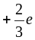
Down (d) | 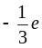
Charmed (c)
Strange (s)
Top (t)
Bottom (b)
Hadron | Quarks
Proton | 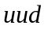
Neutron | 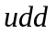
Kaon-minus | 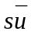
Pi-plus (π⁺) | 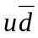
Sigma-plus
Lambda-zero | 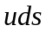
Charmed Omega

- Determine the charge (coulombs) of the Lambda-zero: (+2/3) + (-1/3) + (-1/3) = 0 C ✓
(1)
- Determine the charge (coulombs) of the Kaon-minus: (-1/3)+(-2/3) =-1e =-1.60 × 10⁻¹⁹ C ✓
(1)

- Briefly explain why quarks of like charge are not repelled from each other in a hadron.
(2)
Any reasonable statement referring to either (residual) strong nuclear force / colour charge / gluon exchange ✓ leading to attractive force stronger than electromagnetic repulsion between individual quarks ✓

Question 13
A source of sound waves can be directed through air at 25ºC towards an 8.65 cm gap between two wooden blocks. The wave source can emit either.

- Sound waves at a frequency of 5.0 kHz
- Sound waves at a frequency of 500 Hz

Explain briefly which wave will diffract more and why.
(2)
Diffraction is proportional to wavelength. ✓ (more pronounced when λ is greater than gap width)
So B, 500 Hz has longer λ than opening
5.00 kHz has λ slightly less than opening.✓
(λ = v / f = 346 / 500 = 0.692 m > 0.0865 m)

End of Section One
Section Two: Problem-solving 50% (90 Marks)

This section has eight (8) questions. You must answer all questions. Write your answers in the space provided. Suggested working time for this section is 90 minutes.

Question 14 (13 marks)

A satellite is in orbit around the equator of the Earth. It has a mass of 1495 kg and is at an altitude of 1.91 × 10⁴ km above the Earth’s surface.

Satellite
View of Earth from above North Pole

- Calculate the period of this satellite and state your answer in hours..
(4)
M = 5.98  10²⁴ kg
r = altitude + r_{earth} = 6.37  10⁶ + 1.91  10⁷ = 2.547  10⁷ m ✓

v² / r = GM / r² (substituting v = 2πr / T)
r³ = (G.M.T²) / (4.π²)

T² = (r³.4.π²)/ (G.M)
T² = ((2.547  10⁷)³.4.π²)/ (6.67  10⁻¹¹  5.98 × 10²⁴) ✓
T = 4.044  10⁴ s ✓
T = 4.044  10⁴ / (60 × 60) = 11.2 hours ✓

- Explain whether or not a satellite can be geostationary at this altitude.
(2)
No
The equation T² = (r³.4.π²)/ (G.M) shows that the period of a satellite is fixed at a given radius of separation. The radius must increase to give a period of 24 hours. ✓ ✓

- Place labelled arrow(s) on the diagram to show the direction of the net acceleration of the satellite.
(1)
Towards centre of circle. ✓

- Give two examples of the uses of artificial satellites in everyday life.
(2)
Communications satellites to transmit telephone signals around the globe. ✓
GPS system for navigation.✓
Any 2 reasonable answers

The Earth is a natural satellite that orbits the Sun. (Assume a circular orbit for this question)

- Calculate the orbital speed of the Earth as it goes around the Sun.
(3)

M = 1.99  10³⁰ kg r = 1.50  10¹¹ m ✓

v² / r = GM / r²
v² = GM / r
v² = 6.67  10⁻¹¹  1.99  10³⁰ / 1.50  10¹¹ ✓

v = 2.97  10⁴ m s⁻¹ ✓

Alternatively v = 2πr/T (T = 365.25  24  60  60)

- If the Sun was 90% of its current mass, describe how the orbital speed of the Earth would be affected if it remained at the same distance from Sun. (A calculation is not required)
(1)
Referring to previous equation v² = GM / r
If mass of the sun M decreases then v also decreases. ✓

Question 15 (13 marks)

An eagle has captured a fish and is 14.7 m directly above the water when it releases the fish. The eagle is moving with a velocity of 5.20 m s⁻¹ at an angle of 36.6º above the horizontal when the fish is released. Ignore air resistance for calculations.

5.20 m s⁻¹

36.6°

14.7 m
This diagram is NOT to scale

- Calculate the time taken for the fish to reach the water.
(4)
Positive is taken as upwards for vertical motion in this solution

u_{v} = 5.20  sin 36.6º = +3.10 m/s
s_{v} = -14.7 m ✓
a = -9.8 m/s²

Solve for final vertical velocity at displacement of -14.7 m
v² = u² + 2.a.s
v² = +3.10 ² + (2-9.8-14.7) ✓
v = -17.2549 m/s (take negative root as fish is travelling down) ✓

v = u + at
t = (v – u) / a
t = (-17.2549 – 3.10) / -9.8
t = 2.077 = 2.08 seconds (3 sig figs) ✓

Or general solution of a quadratic.

- Calculate the horizontal distance that the fish travels during its flight back to water.
(3)

u_{h} = 5.20  cos 36.6º = 4.17465 m/s right ✓

s_{h} = u_{h}  t_{f}
s_{h} = 4.17465  2.077 ✓
s_{h} = 8.67 m right ✓

- Calculate the maximum height above the water that the fish reaches during its flight.
(3)
v_{v} at max height = 0 a = -9.8 m/s² u_{v} = +3.10 m/s

v² = u² + 2.a.s
s_{v} = (v² – u²) / 2a
s_{v} = (0 – 3.1²) / -19.6 ✓
s_{v} = 0.490 m above launch ✓

s above water = 0.490 + 14.7 = 15.19 m = 15.2 m (3 sig figs) ✓

If air resistance is taken into account then the flight path is altered.

- Sketch the altered flight path onto the diagram.
Shows reduced max height, range and steeper descent ✓
(1)

- Will the time of flight be longer or shorter when air resistance is taken into account? Discuss the factors that affect this.
(2)
Air resistance acting against the projectile will slow its vertical ascent and descent (e.g. like a parachute).
The maximum height (0.49 m above launch position) is reduced but the time to fall the smaller total distance is increased by air resistance. ✓ So flight time will probably increase. ✓ Any well structured discussion.

Question 16 (12 marks)

A mining company use an electric pump with an operating voltage in the range 1.25 kV-1.50 kV.
There is only a 240 V_{RMS} supply available. A transformer is used to step up the output voltage to 1.50 kV_{RMS}. The secondary winding of the transformer has 2000 turns of wire.

240 V
1.50 kV
Electric Lift (V_{d} = 1.45 kV)
Cables
Transformer

- Calculate the number of turns required on the primary winding of the transformer.
(2)
V_{p} = 240 V V_{s} = 1500 V N_{s} = 2000

V_{s} / V_{p} = N_{s} / N_{p}

1500 / 240 = 2000 / N_{p} ✓
N_{p} = 320 turns ✓

The transformer has an electrical power output of 6.45 kW. The underground pump is connected by 1.10 km of cables to the surface. The potential difference across the pump is 1.45 kV.

- Calculate the total resistance of the cables. (4)

P_{s} = 6450 W V_{s} = 1500 V I_{s} = ?

P_{s} = V_{s}  I_{s}
I_{s} = P_{s} / V_{s} = 6450 / 1500
I_{s} = 4.30 A ✓

V_{cables} = 1500 – 1450 = 50.0 V ✓

R = V_{cables} / I_{s} = 50 / 4.3 ✓

R = 11.6279 Ω = 11.6 Ω (3 sig fis) ✓

- Calculate how much electrical energy per second is transformed to heat in the cables.
(2)
P_{cable} = ? V_{cable} = 50 V I_{s} = 4.30 A

P_{cable} = V_{cable}  I_{s} = 50.0  4.30 ✓
P_{cable} = 215 W ✓

OR P_{cable} = V_{cable}² / R_{cable} = 50² / 11.6279 = 215 W

OR P_{cable} = I_{cable}²  R_{cable} = 4.30² × 11.6279 = 215 W

- Describe two design features of a commercial transformer that increase its efficiency.
(2)
Laminated soft iron core – to reduce flow of Eddy currents which transform electrical energy to heat. ✓

Using larger diameter wires on the windings to reduces heat loss in the wire. ✓

Oil cooling or cooling fins to minimise build up of heat which would cause increased resistance.

Any 2 reasonable answers.

- Explain why it is more efficient to transfer electricity to the pump at a high voltage of 1.50 kV rather than 240 V.
(2)
By considering the equation for power output from a transformer it is evident that Power output can be fixed by increasing V_{output} and decreasing I_{output} (P_{output} = V_{output} × I_{output}) ✓

For cables of a given resistance power loss is reduced if current is reduced as indicated by the equation P_{loss} = I².R_{cable} ✓
(Higher current leads to greater energy loss due to heating.)

Question 17 (13 marks)

The diagram below shows an AC generator consisting of a rectangular coil with dimensions of
14.0 cm × 21.0 cm, and 800 turns of copper wire. The magnetic flux density between the poles is 9.40 mT. The coil is turned at a uniform rate.
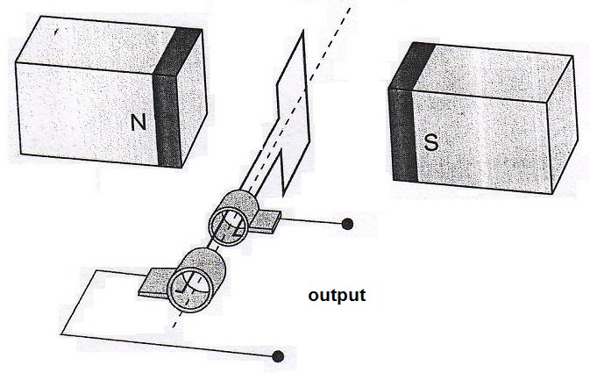
SR
B
B

- Explain the function of the components labelled SR and B.
(2)
SR = Slip rings are the rotating electrical contacts that move with the coil. They are in contact with:
B = brushes are the fixed electrical contacts that link to the external circuit.
This arrangement allows transfer of electricity from the rotating coil to the output stage. ✓ ✓

- Referring to Lenz’s law, explain how induced emf is achieved from such a generator and why the output is a sine or cosine shape rather than being constant.
(3)
As the coil rotates the amount of flux contained within the coil changes. Lenz’s Law states that the emf is generated in the coil that induces current to flow ✓ in a direction such that its own field will oppose the change in the magnetic field that caused it to be generated✓
The emf is proportional to the rate of change of flux (amount of field lines being cut). The rate of change is zero when maximum flux is contained and maximum when the flux is zero. This leads to the sine shape of output voltage. ✓
Or similar.

- The coil is rotated at 1500 rpm. Calculate the magnitude of the average induced emf in the coil as it rotates through 90º from the position shown.
(3)
N = 800 1500 rpm → f= 1500 / 60 = 25.0 Hz
Time for 1 revolution = Period = 1/f = 1/25 = 0.04 s
Time for ¼ revolution = 0.01 s
Φ₁ = B.A = 9.40  10⁻³  0.14  0.21 = 2.7636  10⁻⁴
Φ₂ = 0 ✓

emf = -N(Φ₂ - Φ₁) / t = -800  (0 - 2.7636  10⁻⁴) / 0.01 ✓

emf = 22.1 V ✓

- Sketch the emf output curve for this AC generator on the graph below. You must start from the position shown on the diagram and continue up to 80 ms. Make estimates for values that you cannot calculate.
Initial emf = zero ✓ period = 40 ms ✓ max emf shown larger than average. ✓ (NB peak emf = V_{RMS}  √2
¼ turn method has approx -10% error compared to RMS
‘750 rpm curve’

(3)
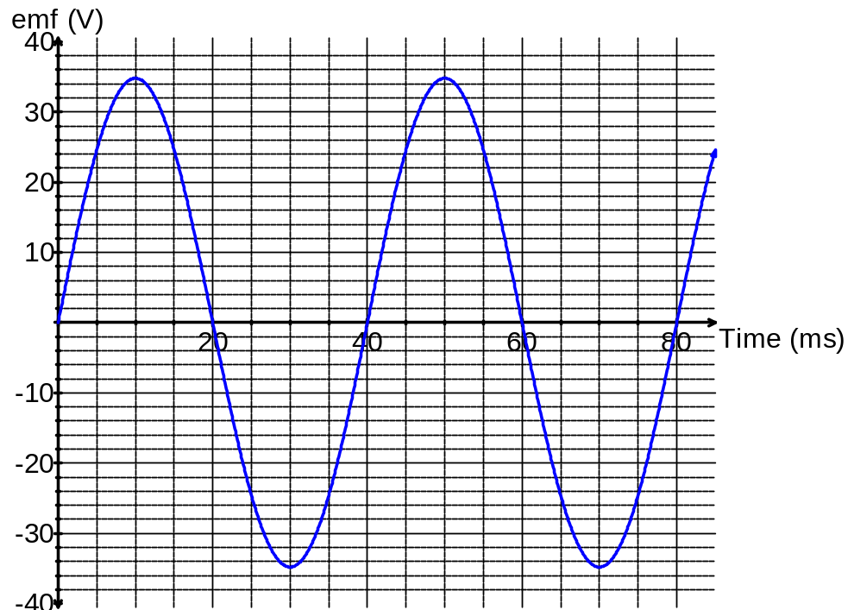

- Indicate three times on the graph when the flux enclosed by the coil is a maximum value at 1500 rpm. Circle these times.
(1)
Times are 0 20 40 60 or 80 ms when the emf = zero. Any 3 ✓

- When the coil is rotated at 750 rpm the emf output changes. Sketch a second voltage curve onto the graph and clearly label it ‘750 rpm curve’.
(1)
Shows Period = 80 ms and emf max is ½ of 1500 rpm curve✓

Question 18 (13 marks)

The diagram below details some of the energy levels for a metallic vapour that surrounds a star

0 eV E∞
-0.81 eV E5
-2.20 eV E4

-3.17 eV E3

-5.54 eV E2

-8.92 eV E1 ground state

- Is it possible for this atom to absorb a 6.50 eV photon whilst in the ground state? Explain briefly.
(1)
No, there is no energy level difference that exactly matches 6.50 eV A photon can only give all or nothing of its energy. ✓

- Whilst in the ground state the atom absorbs a 6.72 eV photon. How many lines in the emission spectrum would be possible as the atom de-excites? Indicate them on the diagram.
(1)
6 lines as per diagram. ✓
Number of lines = 6

- Calculate the longest wavelength possible in the emission spectrum when an atomic electron at E4 can de-excite by one or more steps to ground level.
(3)
Longest λ = lowest frequency, so lowest energy level difference
E = E4 – E3 = absolute value of 3.17 – 2.20 = 0.97 eV✓

E = h.f = h.c / λ

λ = (h.c) / E = (6.63  10⁻³⁴  3  10⁸) / (0.97  1.60  10⁻¹⁹) ✓
λ = 1281 nm ✓ (1.28  10⁻⁶ m)

- For the wavelength you calculated in part c) state which area of the electromagnetic spectrum this belongs to.
(1)
Infra-red. ✓ N.B. 1.281  10⁻⁶ = 10^{-5.89} (by logarithms – this makes it easier to interpret the CC logarithmic scales)

A single atom in the ground state is bombarded by one electron with a kinetic energy of 6.10 eV.

- Detail in the table below the possible photon energies observable on de-excitation and the possible bombarding electron energies after passing through the atom.
(3)
-8.92 + 6.10 = -2.82 eV, so excitation to E3 -3.17 eV is highest possible

Possible photon energies on de-excitation (eV) | Possible bombarding electron energy after passing through the atom (eV)
(E3-E1 8.92 – 3.17) = 5.75 eV  (E2-E1 8.92 – 5.54) = 3.38 eV  (E3-E2 5.54 – 3.17) = 2.37 eV | (6.10 – 5.75) = 0.35 eV  (6.10 – 3.38) = 2.72 eV  6.10 eV (passes through with no collision)
Subtract 1 mark for any incorrect answer

- Explain briefly how analysis of a line absorption spectrum of light coming from space is useful to determine the composition of stars and gas clouds in distant galaxies.
(2)
The line absorption spectrum for each atom is a unique set of frequencies corresponding to energy level differences within that atom. This “fingerprint” allows the atom to be identified from data obtained on Earth.

As a continuous spectrum passes through gas clouds or the outer atmosphere of stars the absorption spectra are formed.

This light continues and is observed on Earth. ✓ ✓ or similar

- The line absorption spectrum is also useful to determine the speed of a galaxy. Explain the fundamental principles of this technique.
(2)
When a light source is moving away from an observer the wavelengths in the absorption spectrum become longer. This is known as ‘red shift’. The amount of red shift can be used to determine recessional speed. ✓ ✓ or similar.

Question 19 (13 marks)

A simple musical instrument consists of one steel string held in tension between two moveable bridges. The string is plucked between the bridges so that a musical note is heard. When the sound wave is analysed it can be seen that several frequencies are present at the same time.
Length
Moveable bridge
Tension peg
Moveable bridge

- Explain why several frequencies of sound are present when the single string is plucked.
(2)
A single ‘note’ from the instrument comprises the fundamental frequency and harmonics (overtones) mathematically related to the fundamental frequency that occur together.
The different frequencies form as a result of resonance. When the string is plucked standing waves form with wavelengths related to the length of the string, the transverse wave speed along the string and the location of particle displacement nodes at each end of the string. ✓ ✓

or similar

- Explain how standing waves can form along the string.
(2)
When the string is plucked progressive transverse waves move along the string and are reflected from the fixed ends. (with a phase change of λ/2)
The reflected wave train interacts with the incoming waves providing the conditions necessary for a standing wave to form. 2 waves with equal frequency/wavelength moving in opposite directions at the same speed interfere with each other along a 1 dimensional line.
✓ ✓ Or similar

- The length of the string is set to 30.0 cm and the speed of the transverse waves along the string is 535 m s⁻¹. Calculate the fundamental frequency of the string.
(3)
L = λ / 2 for the fundamental frequency of the string

λ = 2  L = 2  0.3 = 0.600 m

f = v / λ = 535 / 0.6

f = 892 Hz (3 sig figs)

For a given note played on a musical instrument, the dominant frequency heard is called the fundamental frequency or the first harmonic. The sequence of harmonic frequencies above the fundamental frequency, that are actually present, are known as overtones. So those harmonics above the fundamental are known as the first overtone, the second overtone etc.

- The bridges can be moved and the tension set so that the wave speed along the string stays the same. What length of string is required so that its fundamental frequency is the same as the 2nd overtone of the 30 cm string?
(1)
Wave envelope of 2nd overtone = 3rd harmonic

Equal wavelength for new fundamental:
So new length = 30 /3 = 10 cm ✓

Another simple musical instrument is a pipe, which is an air column closed at one end.

- Sketch the particle displacement wave envelope for the second overtone in the closed pipe.
(2)
Correct shape ✓ correct node locations ✓

- Calculate the frequency of the second overtone in a closed pipe of length 15.0 cm when the air temperature is 25ºC.
(3)
L = 5λ / 4 v = 346 m s⁻¹
λ = 4L / 5 = 4  0.15 /5
λ = 0.12 m ✓

v = f.λ
f = v / λ = 346 / 0.12 ✓ = 2883.33
f = 2.88  10³ Hz ✓

Question 20 (7 marks)

The figure below represents a DC motor whose coil is initially stationary.
- JK = LM = 16.0 cm KL = JM = 12.0 cm
- The coil has 120 turns of wire
- The uniform magnetic flux density between the poles = 95.0 mT
- The current in the coil is 6.30 A when the motor is switched on and it turns clockwise.
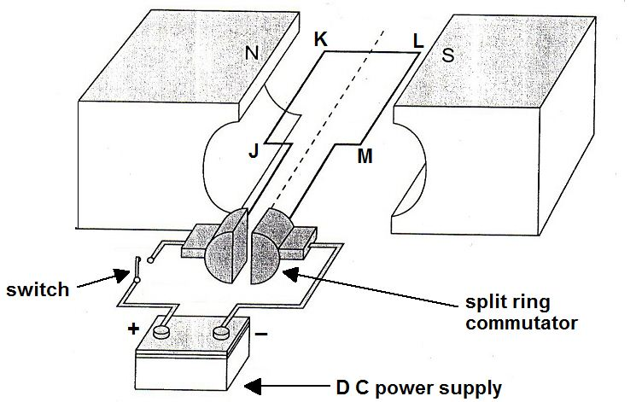
Terminal polarity: -
Terminal polarity:+
Rotation

- Indicate the positive and negative terminals on the DC power supply for this direction of rotation.
Negative left, positive right ✓
(1)

- Calculate the force acting on side LM of the coil when the switch is closed.
(2)
F = B.I.l.N
F = 0.095  6.30  0.16  120✓
F = 11.5 N down ✓

- Calculate the maximum torque that this motor can produce.
(2)
τ_{max} = 2  r.F.sin θ θ = 90°
τ_{max} = 2  0.06 11.5  sin 90°✓
τ_{max} = 1.38 N m clockwise ✓

- How much torque will the motor produce when it has rotated 70º from the position shown. Express your answer as a percentage of the maximum torque.
(2)
τ_{max} = 2  r.F.sin 90 If rotation = 70° then θ = 20° ✓
sin 20° = 0.3420 so τ = 34.2 % of τ_{max} ✓

Question 21 (6 marks)

Alpha particles (He²⁺) are doubly charged positive ions. They are accelerated through an electric field between charged parallel plates before entering a vacuum chamber where they are deflected by a magnetic field.

Alpha particles
Vacuum Chamber
Charged plates
Ion Accelerator
Deflection in magnetic field
❒    

❒    

❒    

❒    

❒    

- Calculate the potential difference between the charged plates in the Ion Accelerator that will give the alpha particles a maximum velocity of 3.40 × 10⁵ m s⁻¹
(3)
q= +3.20  10⁻¹⁹ C v = 3.40  10⁵ m/s
mass of alpha = 6.65  10⁻²⁷ kg ✓
W_{d} = V.q Work done = ΔKE
½ m v² = V.q
V = (½ m v² )/ q = ( ½ 6.65  10⁻²⁷ (3.40  10⁵)²) / +3.20  10⁻¹⁹ ✓
V = 1201.15625 = 1.20  10³ V ✓

- Indicate on the diagram, the direction of the magnetic field within the vacuum chamber that will cause the deflection shown.
Into Page   ✓
(1)

- The magnetic flux density within the chamber is set to 72.5 mT. Calculate the magnitude of force experienced by an alpha particle travelling at 3.40 × 10⁵ m s⁻¹.
(2)
F = q.v.B
F = 3.20  10⁻¹⁹ 3.40  10⁵  0.0725 ✓
F = 7.888  10⁻¹⁵ N = 7.89  10⁻¹⁵ N (3 sig figs) ✓

End of Section 2
Section Three: Comprehension 20% (36 Marks)

This section contains two (2) questions. You must answer both questions. Write your answers in the space provided. Suggested working time for this section is 40 minutes.

Question 22 Hubble’s Law (18 marks)

When a source of waves is moving, a stationary observer notices a change in frequency of the waves. This effect is observed for both longitudinal and transverse waves. For example, if an ambulance moves towards you the sound frequency you hear is higher than the frequency its siren is emitting. This is known as the Doppler Effect.

If a source of electromagnetic waves, such as a star, is travelling away from an observer then the wavelengths of the lines in its electromagnetic spectrum are shifted to higher values. This is called red shift. An equation for the relationship is as follows:
z = red shift
Δλ = change in wavelength (moving source) (nm)
λ = wavelength of stationery source (nm)
v = recessional speed of galaxy (m s⁻¹)
c₀ = speed of light in a vacuum (m s⁻¹)

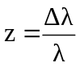 It can also be shown that: 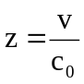

Edwin Hubble analysed the red shifts of various galaxies in 1920 and deduced that most galaxies are moving away from the Earth, this suggests that the Universe is expanding. Hubble also discovered that the further away a galaxy is, the bigger its red shift and the faster it is moving away. This relationship is known as Hubble’s Law and can be stated algebraically as follows:
v_{galaxy} = recessional speed of galaxy (km s⁻¹)
d = distance to galaxy (Mpc)
H₀ = Hubble’s constant (km s⁻¹ Mpc⁻¹)

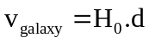

The distances to galaxies can be estimated by observing Cepheid Variables within a galaxy. A Cepheid Variable is a class of star that pulsates. The relationship between the period of pulsation and the size of the star is very precise. An understanding of how brightness diminishes with distance allows astronomers to estimate distances to galaxies with a high degree of confidence.

The following data was recorded by the Hubble Space Telescope for five galaxies.

Distance  (Mpc) | Red shift - z | Recessional speed of galaxy v_{galaxy} (km s⁻¹)
3.1 | 0.00095 | 285
8.6 | 0.00212 | 636
12.2 | 0.00273 | 819
16.1 | 0.00402 | 1206
19.4 | 0.00473 | 1419

- Fill in appropriate values in the final column of the table (the first value has been done for you)
As above ✓✓
(2)

- Plot a correctly labelled graph of recessional speed versus distance to galaxy on the graph paper and draw a line of best fit .
(4)
Correct plotting ✓ labels✓ units✓ line of best fit ✓



- Calculate a value for Hubble’s constant, in the correct units, showing how you obtained this value from your graph.
(3)
Identifies rise and run on line of best fit ✓ (not data points)

H₀ = gradient = rise / run
H₀ = 1440 / 20 ✓
H₀ = 72.0 km s⁻¹ Mpc⁻¹ ✓
Allow small range for “line of best fit” variations.

- State three reasons why you think that measurements of Hubble’s constant have varied widely since Hubble’s first determination in 1920.
(3)
- Improved technology to measure red shift (diffraction gratings)
- Better telescopes (e.g. Hubble and others located in space – no atmospheric distortion.)
- More Cepheid Variables discovered – better averages on distance measurements.
Any 3 credible points ✓ ✓ ✓

- Why does the value of red shift z, have no units?
(1)
Same units top and bottom so it is a ratio of length ✓

- A line in the spectrum of ionised calcium has a wavelength of 393.3 nm when measured in the laboratory. When similar light from the galaxy NGC 3350 is measured, its wavelength is 394.64 nm. Use the red shift formulae to determine the recessional speed of this galaxy.
(2)

Δλ / λ = v / c₀

v = (Δλ  c₀) /λ
v = ((394.64 – 393.3)  3  10⁸ ) / 393.3 ✓
v = 1.02  10⁶ m/s ✓ ( = 1.02  10³ km/s )

- For the recessional speed you calculated in part f), use your graph and line of best fit to determine the distance to this galaxy in Mpc.
(1)
From the graph is approximately 14 Mpc ✓

- Determine how many years it takes for light from galaxy NGC 3350 to reach Earth.
(1 parsec = 3.26 ly)
(2)
14 Mpc = 14  10⁶  3.26 = 45.64 million light years
✓
So it takes light approximately 45.6 million years to reach Earth
✓
Suggest a range be allowed.

Additional working space and spare graph paper

Question 23 (18 marks)
Particle Physics – basic principles and techniques

Particle physics is the modern version of the age old quest – to find the smallest particles that cannot be broken down. Particle accelerators are the ‘laboratory equipment’ in this area of study. Charged particles can be accelerated in two senses – by their change of direction in circular paths or by increasing their speed. Studies can be made on the radiation that they emit whilst being accelerated or the after effects of collisions between high speed particles.

The cyclotron first came into use in 1928 using a combination of magnetic and electric fields to accelerate particles in a spiral path. Development of this technology led to the synchrotron which uses an evacuated circular tube with many magnets placed around its circumference. As particles are accelerated the electric field is adjusted and the strength of the magnets is increased to maintain a constant radius and compensate for relativistic effects that become important at high particle energies.

Any charged particle that accelerates will radiate electromagnetic energy. This is true even at a constant speed in a circular path. So a continual supply of energy is required in synchrotrons to just maintain a constant particle speed let alone increase their speed. The emitted radiation is known as synchrotron radiation and can cover the entire electromagnetic spectrum.

Linear accelerators (LINAC) use a straight path and a series of accelerating voltages as the particles move along the line. LINACs are often used to provide the early stages of acceleration before particles are fed into large synchrotrons.

Collider experiments take two beams of particles that have been separately accelerated in opposite directions and smash them into each other. This is difficult to achieve but if successful it is an efficient use of energy.

When two particles with an equal magnitude of momentum collide head on, the total momentum is zero before and after the collision. If particles are stationary after the collision then their kinetic energy is zero. By the conservation of energy and mass principle, the energy before the collision is transformed into the mass of new particles formed in the collision. The particles that are present after a collision reaction can be different to those that went in. This is exactly what particle physicists aim to achieve and the discovery and study of these new particles underpins their work.

Every collision is governed by one of the fundamental forces (except the force of gravity which has no significant influence on such tiny particles in this context):

- The electromagnetic force leads to simple collisions between charged particles. No new particles are formed when this force is at work. e.g. 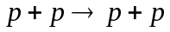
- The strong force dominates reactions between hadrons (which contain quarks). e.g.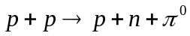
- The weak force is likely to be involved in lepton reactions, especially if one of the leptons is a neutrino. e.g. 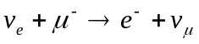
Einstein’s theory of special relativity has led us to the idea that the mass of a moving object is not the same as its rest mass (m₀). The mass of a moving object cannot be measured directly; it must be calculated from a measurement of momentum and velocity. The relativistic equations for momentum p and total energy E are as follows:

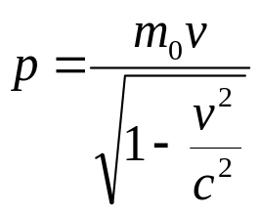 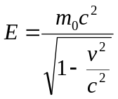 (These equations are only applicable for non-zero mass)

Relativity has also given us the idea of mass-energy equivalence. In Newton’s version of mechanics a lone particle not influenced by gravity or electromagnetism but moving at a given speed could only have a single form of energy – kinetic. At rest it had no energy at all. This is not the case in relativity. The relationship is described by the equation: 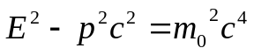

Photons are packets of energy travelling at the speed of light. Surprisingly it has been proved that although photons have zero mass they do have momentum. It can be shown for a photon that
if: then: 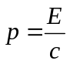 and since 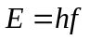 then: 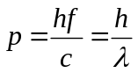

Particle physics has also proven to be vital in understanding the nature of the universe a few fractions of a second after the Big Bang. The conditions created in the mightiest accelerators are very similar to those that existed when the universe was 10⁻¹² seconds old.

Questions

- In what sense can a particle be accelerated if its speed remains constant? Explain.
(2)
Velocity has magnitude and direction. ✓
If a particle undergoes circular motion, a change in direction is also acceleration. ✓

- Once a charged particle has been accelerated to a given speed in a circular path, is further energy required to maintain a constant speed? Explain.
(2)
Yes it radiates synchrotron radiation ✓ so this energy must be replaced. ✓

- Can electrons and neutrinos be subject to the strong force? Explain
(2)
No ✓
The strong (nuclear) force only acts between hadrons / nucleons / quarks ✓

- If neutrinos are involved in a collision reaction why is it unlikely that this was governed by the electromagnetic force?
(1)
Because neutrinos have no charge so they are not influenced by the electromagnetic force.✓

- If you hit a ping pong ball with a table tennis bat which of the three fundamental forces described governs this collision? Justify your answer.
(2)
the electromagnetic force ✓because he strong force acts within a nucleus; the weak nuclear force is involved with beta decay ✓

(Involves the interaction between like charges within the bat and ball.)

Or other reasonable explanation.

- Calculate the momentum of a proton travelling at 95% of the speed of light. The rest mass of a proton is given in the formula and constant sheet.
(3)

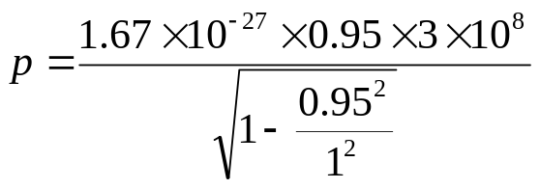

Substitutes correct values✓
Correct handling of denominator✓

Solves to p = 1.524  10⁻¹⁸ ✓ (kg m s⁻¹)

Units desirable but not essential

- The equation for Einstein’s mass-energy equivalence is:
Show that for a particle at rest this simplifies to E = m₀ .c²
(2)
If v = 0
then equals zero (applicable as non zero mass)✓

So simplifies to E² = m₀².c⁴

By taking the square root on both sides then E = m₀.c² ✓

- From the starting point: show that the momentum of a photon with zero mass can be given by 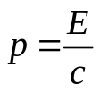
If and m₀ = 0 then E² – p²c² = 0 ✓
So E² = p²c²
p² = E² / c²
Square root of both sides gives ✓
(A photon has zero mass so does not apply to it.)

(2)

- Calculate the momentum of a photon of 550 nm yellow light.
(2)
Using the equation: 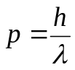, then 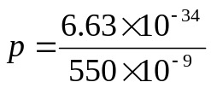✓

p = 1.20545  10⁻²⁷ (kg m s⁻¹ ) ✓

Units desirable but not essential

End of questions

